Erblina Nivokazi 150200917

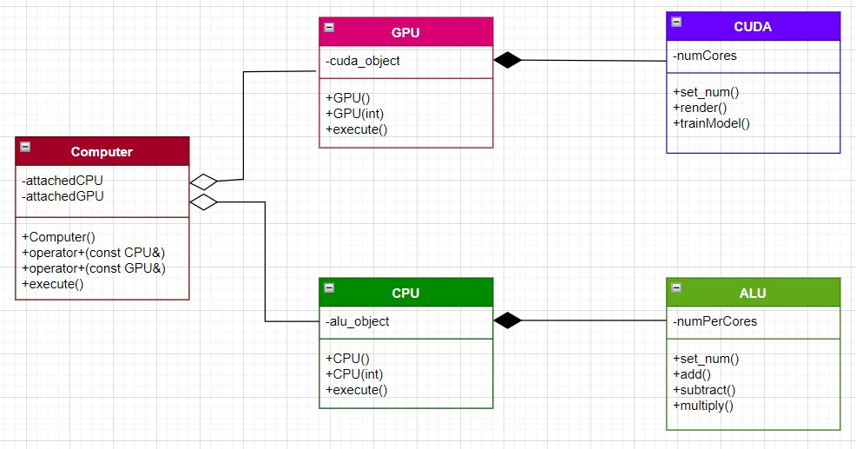

Fig.1 UML Diagram.

The Computer Class is associated with the GPU and CPU class through aggregation, since it contains these classes but GPU and CPU can also exist without the Computer. As for the GPU class with the CUDA class and the CPU class with the ALU class they are associated through composition since CUDA cannot exist without GPU and ALU cannot exist without CPU.

In the Computer class the pointer to CPU and GPU, attachedCPU and attachedGPU, are private members of the class, whereas Computer(), operator+(const CPU&), operator+(const GPU&), and execute() are public members of the class. Computer() is a constructor. Operator+(const CPU&) and operator+(const GPU&) are operator overloaders of the operator + through which we can assign the address of a CPU object to attachedCPU pointer and likewise for GPU. The method execute() is where the operations are called, it takes a string as a parameter.

In the GPU class we have a CUDA class object, cuda_object, which is a private member. The methods of this class are public members, GPU() is a default constructor and GPU(int) is a constructor that takes the number of numCores for CUDA. The method execute() decides with method of the CUDA object is going to get called, it takes a string for parameter.

In the CPU class we have an ALU class object, alu_object, which is a private member of this class. The methods of this class are public members, CPU() is a default constructor and CPU(int) is a constructor that takes the number of numPerCores for the ALU object. The method execute() takes for parameter a string and decides which method of the ALU object is going to get called.

CUDA class has a numCores integer as a private member. Its’ methods are public, set_num() takes as parameter an integer and is used to initialize the numCores integer of the CUDA object. Render() and trainModel() are methods of the two operations that a CUDA object can do.

ALU class has a numPerCores integer as a private member. Its’ methods are public, set_num takes as parameter an integer and is used to initialize the numPerCores integer of the ALU object. The methods add(), subtract(), and multiply() are the operations that anALU can compute.